17027_Vegam_CAD/CAE Report

Author’s Name: Suraksha

Co-Author’s Name:Prathik

1. Introduction

In order to build an efficycle with sound engineering we had to get the dimensioning and tolerances right. So we set our design targets like length, width, curb weight, low costetc.Then we used these parameters for designing.Before starting with the CAD model, we made few design sketches (appendix-2.a). Later we used mechanic set to build the small model of the vehicle to get a fair idea of how our vehicle should look like (appendix-12b).Then we started with the modelling in the software.

The software used for CAD modelling is Autodesk Inventor Professional 2018 andthe software used for CAE analysis is also Autodesk Inventor Professional 2018 .

1. Frame MAterial options
2. Steelalloy(AISI 1018 )  
   Cross-Section Type; 25.4 x 21.4 x 2
3. Steel alloy (AISI 3074)  
   Cross-Section Type; 25.4 x 21.4 x 2
4. Steel alloy (AISI 1020)  
   Cross-Section Type; 25.4 x 21.4 x 2

where;

A = Outer dia for circular section, Bigger side for Rectangular section, Major axis in case of elliptical section etc. (all dimensions in mm or inch)

B= Inner dia for circular section, Smaller side for Rectangular section, Minor axis in case of elliptical section etc. (all dimensions in mm on inch)

t= wall thickness in mm or inch.

|  |  |  |  |
| --- | --- | --- | --- |
| Particulars | AISI 1018 | AISI 3074 | AISI 1020 |
| Thickness (mm) | 2 | 2 | 2 |
| Outer diameter (mm) | 25.4 | 25.4 | 25.4 |
| Yield strength (MPa) | 365 | 373 | 350 |
| Ultimate Strength (MPa) | 440 | 409 | 420 |
| Density(g/cc) | 7.87 | 7.87 | 7.87 |
| Modulus of Elasticity (GPa) | 205 | 210 | 205 |
| Carbon content (%) | 0.14% | 0.05% | 0 |
| Weld ability | good | Excellent | Good |
| Corrosion resistance | Good | Excellent | Good |
| Lead time for delivery (days) | 7 | 5 | 8 |
| Availability | Easily Available | Easily Available | Not Easily Available |
| Cost Rs/m | 105 | 78 | 80 |

1. calculation of bending strength and bending stiffness

***AISI 1018*** (reference)

* Outer Dia -25.4mm
* Inner Dia 21.4mm
* Thickness 2 mm
* σy=365 MPa
* E = 205 GPa

M=(σy*I)/c

I = (π(do4 –di4))/64 =(3.14(25.44-21.44))/64  
 =10136.745 mm4

C = (do-di)/2/2=(25.4-21.4)/2/2=11.7mm

M=(365*10136.745)/11.7 = 316231.7 N/mm2

Bending Stiffness = E*I =2.05 *105 *10136.745 = 2078.032 *106Nmm2

***AISI 3074***

* Outer Dia -25.4mm
* Inner Dia 21.4mm
* Thickness 2mm
* σy=373 MPa
* E = 210GPa

M=(σy*I)/c

I = (π(do4 –di4))/64 =(3.14(25.44-21.44))/64 =10136.745 mm4

C = (do-di)/2/2=(21.4-21.4)/2/2=11.7 mm

M=(373*10136.745)/11.7 = 323162.8N/mm2

Bending Stiffness = E*I =2.10 *105 *323162.8 = 2128.71*106Nmm2

***AISI 1020***

* Outer Dia -25.4mm
* Inner Dia 21.4mm
* Thickness 2mm
* σy=350 MPa
* E = 205GPa

M=(σy*I)/c

I = (π(do4 –di4))/64 =(3.14(25.44-21.44))/64 =10136.745 mm4

C = (do-di)/2/2=(23.4-21.4)/2/2=11.7 mm

M=(350*10136.745)/11.7 = 303235.96 N/mm2

Bending Stiffness = E*I =2.05 *105 *10136.745 = 1064.358 *106Nmm2

|  |  |  |  |
| --- | --- | --- | --- |
| Particulars | AISI 1018 | AISI 3074 | AISI 1020 |
| Bending strength (N/mm2) | 316231.7 | 323162.8 | 303235.96 |
| Bending stiffness (N/mm) | 2078.03*106 | 2128.71*106 | 1064.35 *106 |

1. CAE ANalysis of Vehicle/Frame

{CAE Analysis on the frame should be performed to evaluate the safety offered by the frame to drivers in case of any accident including at least Frontal Impact, Side Impact and Rollover. If possible, the whole vehicle model can be subjected to this safety analysis through CAE. But as a minimum, analysis of frame is required in this report.

*This CAE analysis shall be formed on all materials considered as frame material option as mentioned in Sr. No. 2 above.}*

* 1. Frontal Impact Analysis

**Material-1 (Write Name/Grade, Cross-section Size)**

1. **Assumption& Considerations**:
2. Total mass of the vehicle including drivers, pay load being 400 kg
3. The vehicle was moving at 40 km/h while impact
4. While analysis , the force is applied on the front while the rear was kept rigid .
5. Impact timing being 0.13 seconds.

Mention all the assumptions considered for performing the analysis for frontal impact on frame/vehicle. All material conditions, structure simplification (such as omission of members), boundary conditions, meshing conditions impact conditions should be elaborated in detail.

1. **Calculation of Impact Forces:**

Total mass of the vehicle, M =400N

Initial velocity before impact, Vinitial = 9.72 m/s

Final velocity after impact, Vfinalwill be zero.

Impact time = 0.13 seconds

Work done = change in kinetic energies.

From work energy principal,

Work done = change in kinetic energies   
W = (0.5 × M × Vfinal2 - 0.5 × M × V initial2 )

│W│ = │- 0.5 × M × vinitial2│ =│- 0.5 × 400 × 9.722│ = 18895.68 Nm

Now, Work done = force × displacement= F × s …… (1) s = impact time × vmaximum = 0.13 ×9.72 = 1.263 m So, from (1) we get, F = W/ s = 18895.68 / 1.263 = 14960.94N

The complete calculations for Impact Forces must be presented. Unit of Force shall be in Newton. The total impact forces and their distribution, if any must be presented with the help of FE Model. Teams may use snapshots taken from CAE tools for representation of FE model.

1. **Analysis Results:**

|  |  |  |
| --- | --- | --- |
| Working stress(MPa) | Yield strength (MPa) | FOS |
| 360 | 365 | 0.9 |

*Similarly, show the frontal impact analysis of vehicle/frame with other material options.*

* 1. Side Impact Analysis

**Material-1 (AISI 1018 , 25.4 x 21.4 x 2 )**

1. **Assumption & Considerations**:
2. Each drivers is of 150kg, Curb weight is , thereby having a total mass of
3. The vehicle of ---kg moving at 50 km/h collide from the side
4. While analysis , the force is applied on one side while the other side was kept rigid.
5. Impact time being 0.13 seconds
6. Maximum mass of the vehicle being 400 kg.
7. **Calculation of Impact Forces:**

From work energy principal,

Work done = change in kinetic energies

W = (0.5 × M × vfinal2 - 0.5 × M × vinitial2 )

│W│ = │- 0.5×M×vinitial2│ =│- 0.5 × 3924× 9.722│ = 18895.68 Nm Now,

Work done = force × displacement= F × s

s = impact time × vmaximum = 0.30 × 9.72 = 2.91 m

So, from (1) we get,

F = W/ s = 18895.68/ 2.91 = 6493.36 N

1. **Analysis Results:**

|  |  |  |
| --- | --- | --- |
| Working stress(MPa) | Yield strength (MPa) | FOS |
| 1095 | 365 | 3 |

**Material-2 (AISI 3074 , 25.4 x 21.4 x 2)**

1. **Assumption& Considerations**:
2. Each drivers is of 150kg, Curb weight is , thereby having a total mass of
3. The vehicle of ---kg moving at 50 km/h collide from the side
4. While analysis , the force is applied on one side while the other side was kept rigid.
5. Impact time being 0.13 seconds
6. Maximum mass of the vehicle being 400 kg.
7. **Calculation of Impact Forces:**

From work energy principal,

Work done = change in kinetic energies

W = (0.5 × M × vfinal2 - 0.5 × M × vinitial2 )

│W│ = │- 0.5×M×vinitial2│ =│- 0.5 × 3924× 9.722│ = 18895.68 Nm Now,

Work done = force × displacement= F × s

s = impact time × vmaximum = 0.30 × 9.72 = 2.91 m

So, from (1) we get,

F = W/ s = 18895.68/ 2.91 = 6493.36 N

1. **Analysis Results:**

**Material-3 (AISI 1020 , 25.4 x 21.4 x 2)**

1. **Assumption& Considerations**:
2. Each drivers is of 150kg, Curb weight is , thereby having a total mass of
3. The vehicle of ---kg moving at 50 km/h collide from the side
4. While analysis , the force is applied on one side while the other side was kept rigid.
5. Impact time being 0.13 seconds
6. Maximum mass of the vehicle being 400 kg.
7. **Calculation of Impact Forces:**

From work energy principal,

Work done = change in kinetic energies

W = (0.5 × M × vfinal2 - 0.5 × M × vinitial2 )

│W│ = │- 0.5×M×vinitial2│ =│- 0.5 × 3924× 9.722│ = 18895.68 Nm Now,

Work done = force × displacement= F × s

s = impact time × vmaximum = 0.30 × 9.72 = 2.91 m

So, from (1) we get,

F = W/ s = 18895.68/ 2.91 = 6493.36 N

1. **Analysis Results:**
   1. Rollover Analysis

**Material-1 (AISI 1018 , 25.4 x 21.4 x 2)**

1. **Assumption& Considerations**:
2. Each drivers is of 150kg, Curb weight is , thereby having a total mass of
3. The vehicle was moving at 40 km/h while impact
4. While analysis , the force is applied on the front while the rear was kept rigid .
5. The impact time being kept at 0.13 seconds
6. Maximum mass of the vehicle taken as 400 kg
7. Free fall height 1.5 m.

e as given in 4.1.

1. **Calculation of Impact Forces:**

Impact time = 0.13 s

During the fall, the whole potential changes into kinetic energy,

M × g × h = 0.5 × M × v2

v = √ (2 × g × h) = √ (2 × 9.81 ×1.5) =5.42 m/sec

Now from work energy principal

Work done = change in kinetic energies

│W│ = │- 0.5 × M × vinitial2│ =│- 0.5 × 400 × 5.42│ =1084 Nm

Now,

Work done = force × displacement= F × s

s = impact time × vmaximum = 0.13 × 5.42 = 0.704 m

W= M*g*h = 400*9.81*1.5=5886Nm

, F = W/ s = 5886 / 0.704 = 8360.79N

Same as given in 4.1.

1. **Analysis Results:**

|  |  |  |
| --- | --- | --- |
| Working stress(MPa) | Yield strength(MPa) | FOS |
| 984.8 | 365 | 2.6 |

**Material-2 (AISI 3074 , 25.4 x 21.4 x 2)**

1. **Assumption& Considerations**:
2. Each drivers is of 150kg, Curb weight is , thereby having a total mass of
3. The vehicle was moving at 40 km/h while impact
4. While analysis , the force is applied on the front while the rear was kept rigid .
5. The impact time being kept at 0.13 seconds
6. Maximum mass of the vehicle taken as 400 kg
7. Free fall height 1.5 m.

e as given in 4.1.

1. **Calculation of Impact Forces:**

Impact time = 0.13 s

During the fall, the whole potential changes into kinetic energy,

M × g × h = 0.5 × M × v2

v = √ (2 × g × h) = √ (2 × 9.81 ×1.5) =5.42 m/sec

Now from work energy principal

Work done = change in kinetic energies

│W│ = │- 0.5 × M × vinitial2│ =│- 0.5 × 400 × 5.42│ =1084 Nm

Now,

Work done = force × displacement= F × s

s = impact time × vmaximum = 0.13 × 5.42 = 0.704 m

W= M*g*h = 400*9.81*1.5=5886Nm

, F = W/ s = 5886 / 0.704 = 8360.79N

1. **Analysis Results:**

Same as given in 4.1.

**Material-3 (AISI 1020 , 25.4 x 21.4 x 2)**

1. **Assumption& Considerations**:
2. Each drivers is of 150kg, Curb weight is , thereby having a total mass of
3. The vehicle was moving at 40 km/h while impact
4. While analysis , the force is applied on the front while the rear was kept rigid .
5. The impact time being kept at 0.13 seconds
6. Maximum mass of the vehicle taken as 400 kg
7. Free fall height 1.5 m.

e as given in 4.1.

1. **Calculation of Impact Forces:**

Impact time = 0.13 s

During the fall, the whole potential changes into kinetic energy,

M × g × h = 0.5 × M × v2

v = √ (2 × g × h) = √ (2 × 9.81 ×1.5) =5.42 m/sec

Now from work energy principal

Work done = change in kinetic energies

│W│ = │- 0.5 × M × vinitial2│ =│- 0.5 × 400 × 5.42│ =1084 Nm

Now,

Work done = force × displacement= F × s

s = impact time × vmaximum = 0.13 × 5.42 = 0.704 m

W= M*g*h = 400*9.81*1.5=5886Nm

, F = W/ s = 5886 / 0.704 = 8360.79N

Same as given in 4.1.

1. **Analysis Results:**

Same as given in 4.1.

1. final MATerial selection

{Different materials must be compared on the basis of CAE results and other parameters such as manufacturability, weight of vehicle then represent in tabular format.}

**Materials Selected for Frame:**

1. Material 1 Grade, Cross-Section Type, Size
2. Material 2 Grade, Cross-Section Type, Size
3. **……………….(**List down all selected materials)
4. CAE ANalysis of other parts

**Brake disk analysis**

1. **Assumption& Considerations**:
2. It made of ------material
3. The disk has more chance of failing due to thermal stress than mechanical stresses .
4. The temperature is increaded due to the friction force between the plate and the pads

Mention all the assumptions considered for performing the analysis for frontal impact on frame/vehicle. All material conditions, structure simplification (such as omission of members), boundary conditions, meshing conditions impact conditions should be elaborated in detail.

1. **Calculation of thermal stress**

The complete calculations for Impact Forces must be presented. Unit of Force shall be in Newton. The total impact forces and their distribution, if any must be presented with the help of FE Model. Teams may use snapshots taken from CAE tools for representation of FE model.

1. **Analysis Results:**

{The analysis results such as deformation, stress, safety factor should be given here.

Include the images of results from CAE software}

**Seat back member analysis**

1. **Assumption& Considerations**:
2. The seat is made up of Plywood and cushioning
3. The element in contact with the lower seat was kept rigid
4. Force of 10Mpa was applied the element in contact with the seat back
5. **Calculation of bending stress :**

The complete calculations for Impact Forces must be presented. Unit of Force shall be in Newton. The total impact forces and their distribution, if any must be presented with the help of FE Model. Teams may use snapshots taken from CAE tools for representation of FE model.

1. **Analysis Results:**

{The analysis results such as deformation, stress, safety factor should be given here.

Include the images of results from CAE software}

1. **Optimizations:**

Initially the seatback angle was 30deg, the bending stress was also more , then according to the riders comfort and to reduce the stresses it was optimized to an angle of -----

**Wheel hub analysis**

1. **Assumption& Considerations**:
2. It is made up of ---- material
3. Its diameter is taken as…..
4. The entire weight is distributed among the 3 wheel hub where it fits in to the frame and is subjected to a bending load
5. **Calculation of bending stress:**

The complete calculations for Impact Forces must be presented. Unit of Force shall be in Newton. The total impact forces and their distribution, if any must be presented with the help of FE Model. Teams may use snapshots taken from CAE tools for representation of FE model.

1. **Analysis Results:**

{The analysis results such as deformation, stress, safety factor should be given here.

Include the images of results from CAE software}

1. Vehicle Views

Vehicle views should be included at the **Appendix-1** with all dimensions as asked (all views given at Appendix-1 are mandatory). Complete CAD model with the placement of all components should be shown.

If required more pictures of the CAD model may be inserted at Appendix-1 (e.g. Both side views if the sitting height for both drivers is different in case of adjacent seats, detailed view of subsystems etc.). All the pictures must be full page pictures at Appendix-1 and can be rotated for better presentation.

If the space of CAE images is felt insufficient in the document, these may be placed as **Appendix-2** at the end of report with proper captions and picture numbers. The picture numbers should be referred in the main document content.

All hand sketches, 2D drawings, prototype images may be included in Appendix-2.

**APPENDIX-1 : Vehicle Views**

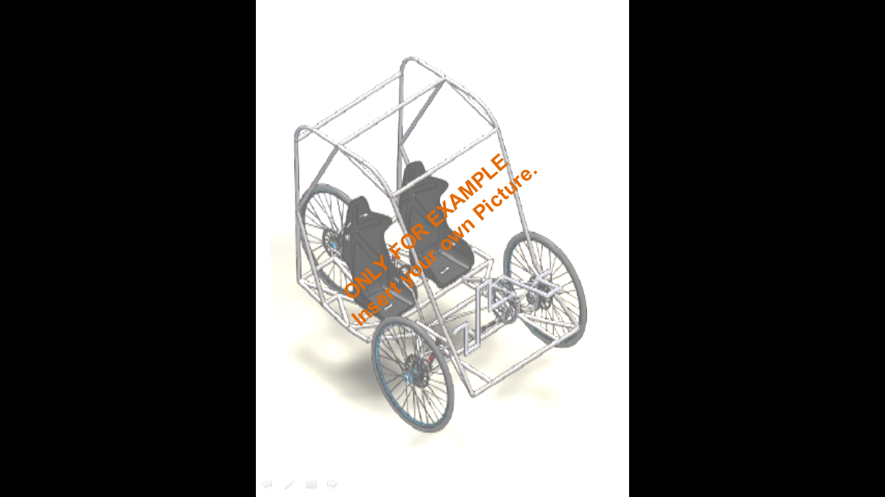

**Figure-1 (Isometric View of Vehicle)**

**APPENDIX-1 : Vehicle Views (contd..)**

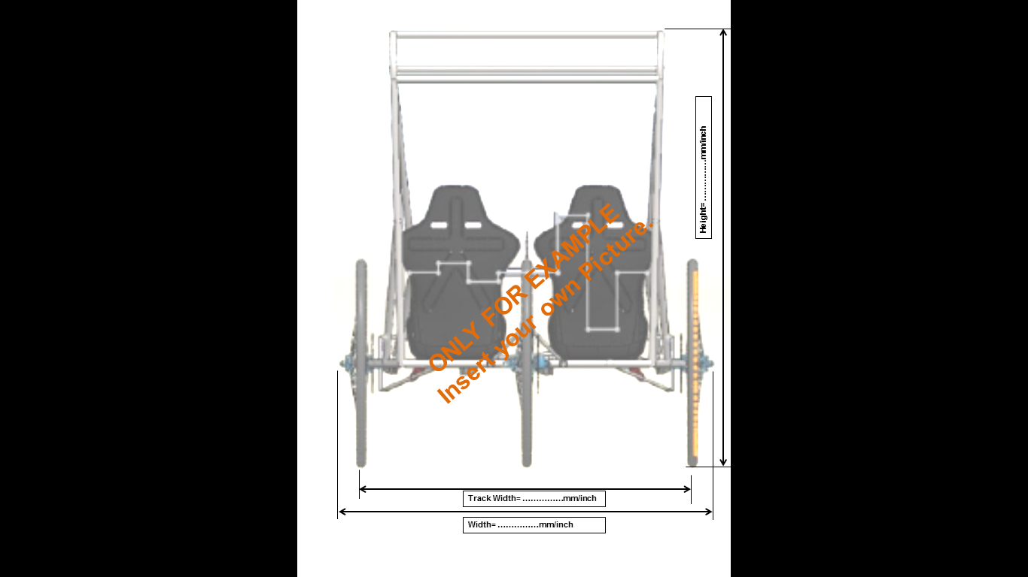

**Figure-2 (Front View of Vehicle)**

**APPENDIX-1 : Vehicle Views (contd..)**

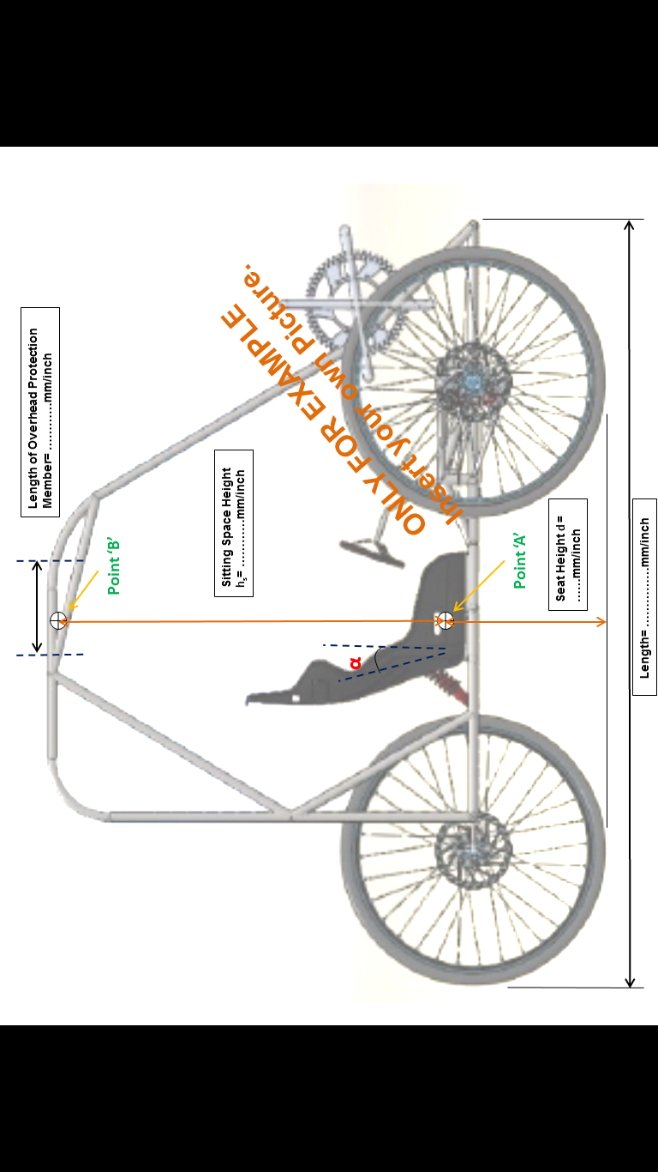

**Figure-3 (Side View of Vehicle)**

**APPENDIX-1 : Vehicle Views (contd..)**

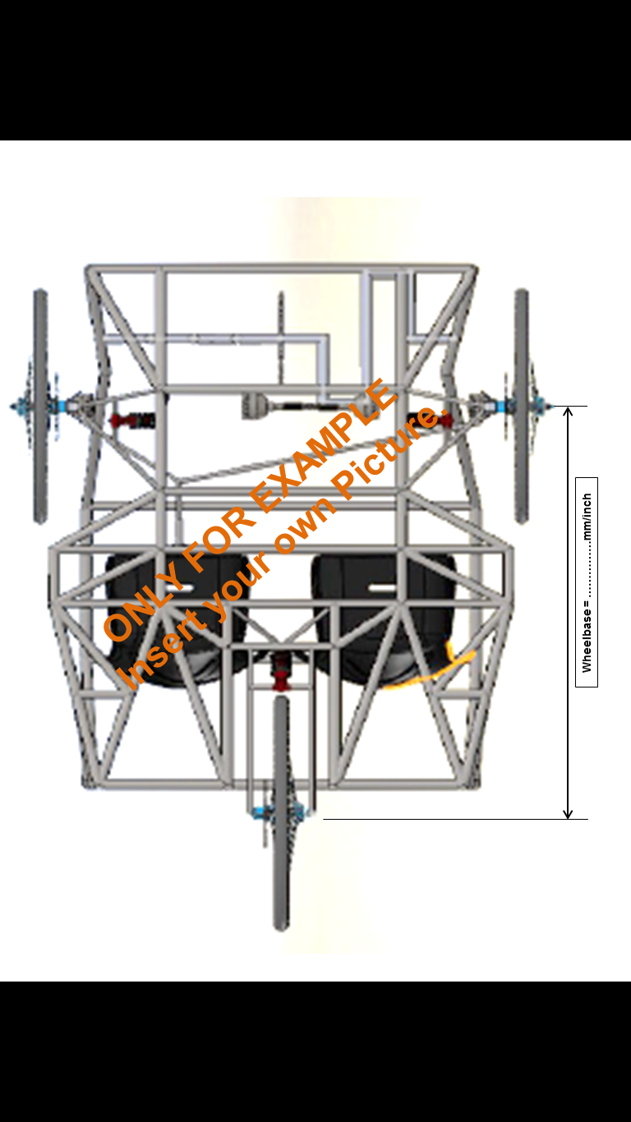

**Figure-4 (Top View of Vehicle)**

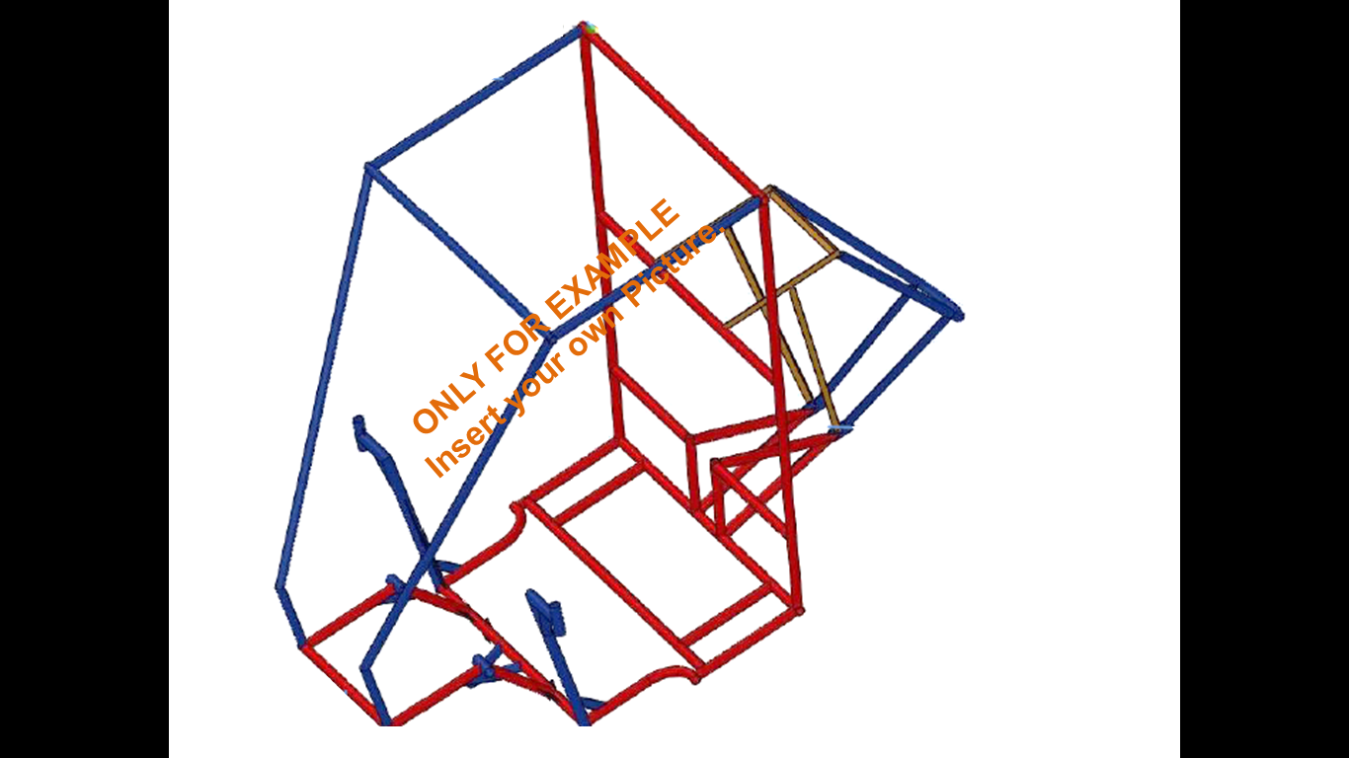**APPENDIX-1 : Vehicle Views (contd..)**

{Different Materials/Cross-section should be shown with different colors.}

**Figure-5 (CAD Model of Frame)**

Guidelines

1. The CAD model must be complete for the presentation in CAD/CAE Report.
2. The document must be prepared in this template only. Change in format (header/footer/sequence) will not be accepted. Any heading cannot be omitted.
3. Document size should not exceed 5MB, whereas number of pages is not restricted.
4. This format is a 97-9003 word template. Document must be saved as **Team ID_TeamName_CAD/CAE Report** as a separate ‘.pdf’ file.
5. The file must be sent to [efficycle.reports@icat.in](mailto:efficycle.reports@icat.in)before 28th July, 2017 05:00pm. Mail subject name must be **Team ID_TeamName_CAD/CAE Report.**
6. Mails not sent with proper subject name or proper file name, as given above, will be summarily reject without any prior intimation and it will be considered as non-submission of document.
7. No request for deadlines extension shall be considered.
8. The font must be “Helvetica”, black, 10 size.

How to use Report template

1. Open the report template. File extension is .dot.
2. Save it as word document with document name **Team ID_TeamName_CAD/CAE Report** (write your team ID and Team name here)
3. Now check the file extension. It should be .doc or .docx.
4. Check that the document has the header and footer same as given in the template.
5. Start writing your content in the new document created by you.
6. After the completion of document, check the format of such as header, footer, 2 columns format, pictures placement etc.
7. Now save as .pdf file and then submit through email as mentioned in guidelines above.